Resume

Basketball coach, P.E. Teacher, senior university lecturer

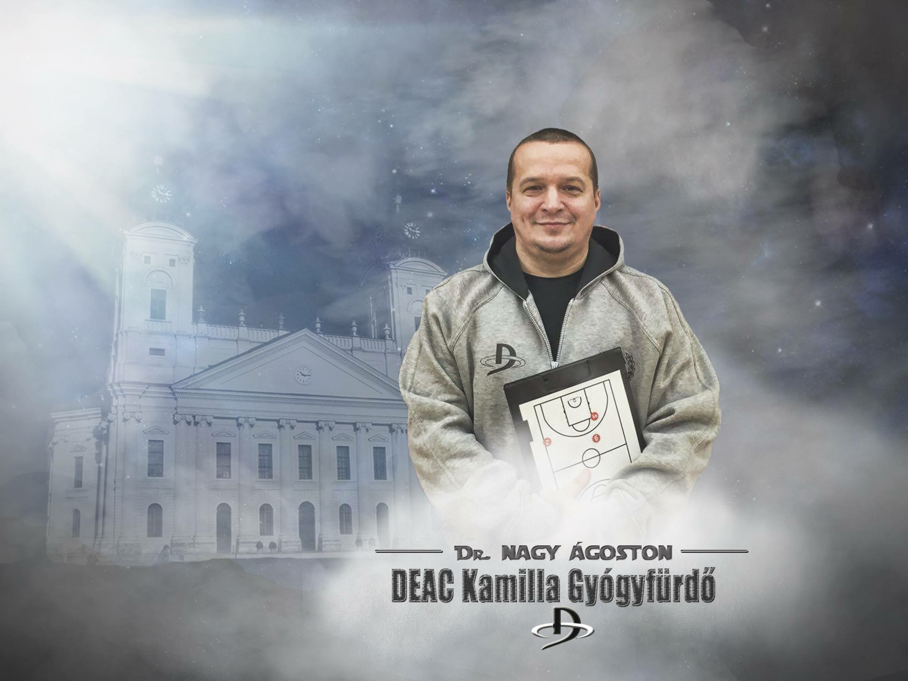

# Coaching experiences since 1992

# Curriculum Vitae

## Coach Ágoston Nagy PhD

## [www.basketclinic.hu](http://www.basketclinic.hu)

**Date of birth:** 1968

**Place of birth**: Debrecen, Hungary

Two sons (1994, 1995) both are basketball players

* Hungarian University of Physical Education - physical education teacher, 1992 Master degree
* Hungarian University of Physical Education - basketball coach, 1994 Master degree
* PhD management and Business administration - sport management 2010

# Recently

University of Debrecen (P.E. teacher, basketball coach and senior university lecturer),  *since 1992*

# Earlier

I was the sport director *(2005-2011)* of the University of Debrecen (*35 000 Students)*

# **Coaching**

* I used to coach with women and men teams on different levels. (pro and youth also, in Hungary and Iceland, Europe) (since 1990-)
* Hungarian National teams U16, U18, U20 on the European Championships

- **Currently coaching the men team (DEAC) in the Hungarian First League in Hungary**

**- I had averaged 130 games a year in the past 15 years, with positive balance.**

# Basketball academical CONCEPTS and Programs

**I wrote *(in 2012)* a full concept and basketball academical program for 6 to 25 years old players. Take a look at this version here:**

<https://www.dropbox.com/s/dwcq7yultpcppng/DKA.P%26k2.pdf?dl=0>

# **Results of the last three years**

* 2nd place in the Hungarian First League B division 2015.
* Won Hungarian University National Championship, 2013, 2014, 2016
* Won Hungarian Hepp Cup 2015.
* 7th place on European University Games in Basketball 2014. Rotterdam
* 15th on European University Games in 2016. Zagreb-Rijeka
* 2nd Hungarian Hepp Cup 2014.
* 3rd Hungárián Hepp Cup 2016
* 2nd place Hungarian University National Championship 2015
* Final Four in International Student basketball League
* 5th and 7th place in European Championship with Youth National Teams
* 2nd u18 men National Championship 2012
* 3rd u18 men National Championship 2013

# VIDEOS

- This is how we play [www.hudl.com/v/bJfBQ](http://www.hudl.com/v/bJfBQ)

- Style of my teams <http://temp-hudlvid.s3.amazonaws.com/65253/132034/a47/566c436630ba2b22c06d0a47/jbs6.mp4>

# Contact info

Email: [gu2sti@basketclinic.hu](mailto:gu2sti@basketclinic.hu)

Twitter: @nagoston

Facebook: <https://www.facebook.com/agoston.nagy.coach>

Web: [www.basketclinic.hu](http://www.basketclinic.hu)

Web: <http://hunsera.site88.net>

Cell: +36 30 9 03 03 23

# Memberships

- Hungarian Coaching Association

- Hungarian Sport Scientific Association

* Hungarian Sport Management Association
* FIBA Coaching Association license

# Active International Public Relations

Russia- International Student Basketball League

Lithuania - LS University Kaunas

Moscow - MG University

Croatia - Cedevita KK basketball club

Slovenia - Rogaska KK basketball club

Iceland - Tindastoll basketball club

Bosnia - Travnik basketball club

France - La Rosh sur Yon basketball club

Estonia - TTU basketball club

Macedonia - Radnicki basketball club

Great Britain - dr. Laszlo Nemeth

Italy - Fabio Fossati

Spain - Jose Maria Buceta

# Public activities and memberships

- Youth committee of Hungarian Basketball Federation

- International Basketball Coaching Association

* FIBA Coaching Association
* Hungarian Educational Research Association

# My university Courses (since 1992)

*Physical education, basketball, methods of sport training, sport management, sport organization, training theory, game theory, sport pedagogy*,

I have been involved in sports sciences and researches since 1991. I examined the technics, tactics, and the psychological, pedagogical and physiological background of basketball. I have got articles and lecture notes of these subjects and presented on trainings.

I have been a lecturer of the Hungarian University of Physical Education since 2007.

Interested in teaching, educating sports, comparing management and basketball strategies and organizations.

Translated many sport books from English to Hungarian.

I provide a basketball web site where I can publish my articles as well. This was the only basketball site in Hungary where you can find scientific contents.

As the sport director of the University of Debrecen (2005-2011) I reserched the new possibilities of the sport life of the university level in Hungary. Due to the results of my studies I worked out many programs, global and partial strategies.

# International Coaching

2007-2008 Hungarian Basketball Federation, - head of the Training Program 1993-1994)

2008-2009 Hungarian Basketball Federation, head of the Training Program (1994 boys)

2009-2010 Hungarian Olympic Committee, head coach of Heraklész program. U16 (1994).

European Championship, Estonia

2010-2011 Hungarian Olympic Committee, head coach of Heraklész program.U18 (1993-94)

European Championship, Bulgaria

# National team players

Ács Balázs, Asztalos Soma, Bajalinov Kristóf, Garamvölgyi Ákos, Mohay Péter, Nagy Botond Ágoston, Nagy Szabolcs, Zahorán Bertold, Vietórisz Ágnes. Andrássy Géza, Nagy Benedek Ágost, Opre Roland

# Club coaching timeline

1992 DSI U18 Debrecen

1993-1995 PRIMA SE men, U18, U16. NBII

1996-1997 **Tindastoll, Iceland pro men team**. Also U18, U16 boys

1998 PRIMA SE men, women **NB IB,** U18, U16, NBII

1999 PRIMA SE men NB II, women **NBI B,** U18, DSI U16 1987-88,

2000 PRIMA SE men NB II, women **NBI B,** DSI U16 1987-88, University and NBI men,

2000.06. Basket Clinic Pro Camp- Head coach of the champions

2001.06.12-15. Big Camp St. Etienne, Franciaország, coach of Lions

2002 PRIMA SE men NBII, Irinyi-PRIMA SE women NBII, Vadkakasok- DSI U16 1989

2003 **DEKE men NB I B**, PRIMA SE men NBII, Vadkakasok DSI U16 1989 boys

2004-2007 DSC-SI 1991, DSI 1993-94 and D-Medikus NBII and DSI 1995

2008 DEKE- DSI NBI A U20, DSC-SI 1991, DSC- SI 1993-94 and DEAC-Medikus men NBII

2009 DEKE-DEAC NBIA U20, DSC-SI 1993-1994, and 1997 DEAC- DSI NBII

2010 **DEAC- DSI NBIB**, DSC-SI 1993-1994, and 1995

2011-…. **DEAC NBIB**, U18, NBII, University

2013 - **DEAC NBIB**, NBII, University leagues

**More results**

2007. National Championship U14 5th (23 games / 21 wins)

2007. National Championship U16 3rd

2009. National Championship U16 2nd (21 games / 20 wins)

2009. National Championship U18 3rd

2010. National Championship U18 7rd

2010. **U16 National team („B” division European Championship 6th**)

2010. NBII 3rd

2011. NB I B men U20 4th

2011. National Championship U18 4th

2011. **U18 National team („B” division European Championship 7th)**

2012. NBIB men U20 3rd

2013. NB I B , U18 3rd National University Championship 1. **European University Championship** 14. Split

2014. NB IB 5th U18 2nd National University Championship 1st. Hepp Cup 2nd. **European University Championship** 7th.

2015. NB IB 2nd. Hepp cup 1st. U20 5. NB II champion Eastern conference , MEFOB 2. NB II 2nd **ISBL Final Four, Moscow**

**2016. NB IB 6th , Hepp Kupa 3. Hely, ISBL 5. hely,**

**National University Championship 1st, NB II champions,**

**European University Games Zagreb-Rijeka, Croatia.**